**Project Planning Phase**

**Project Planning Template (Product Backlog, Sprint Planning, Stories, Story points)**

|  |  |
| --- | --- |
| Date | 01 july 2025 |
| Team ID | LTVIP2025TMID40229 |
| Project Name | Hematovision |
| Maximum Marks | 5 Marks |

**Product Backlog, Sprint Schedule, and Estimation (4 Marks)**

Use the below template to create product backlog and sprint schedule

|  |  |  |  |  |  |  |
| --- | --- | --- | --- | --- | --- | --- |
| **Sprint** | **Functional**  **Requirement (Epic)** | **User Story**  **Number** | **User Story / Task** | **Story Points** | **Priority** | **Team**  **Members** |
| Sprint-1 | Registration | USN-1 | As a user, I can register for the application by entering my email, password, and confirming my password. | 2 | High | Goda  Srinivasulu  Reddy |
| Sprint-1 |  | USN-2 | As a user, I will receive confirmation email once I have registered for the application | 1 | High | Goda  Srinivasulu  Reddy |
| Sprint-2 |  | USN-3 | As a user, I can register for the application through Facebook | 2 | Low | Dudiki Naga  Sowmya |
| Sprint-1 |  | USN-4 | As a user, I can register for the application through Gmail | 2 | Medium | Goda  Srinivasulu  Reddy |
| Sprint-1 | Login | USN-5 | As a user, I can log into the application by entering email & password | 1 | High | Goda  Srinivasulu  Reddy |
| Sprint -3 | Dashboard | USN-6 | As a user, Register in github | 2 | Medium | Gopu  Radhika |
| Sprint -4 |  | USN-7 | As a user, Distributed project as tasks | 1 | Low | Devarapalli Ashok |
| Sprint -2 |  | USN-8 | As a user, completed what I have the task | 2 | Medium | Dudiki Naga  Sowmya |
| Sprint -3 | Word | USN-9 | As a user, completed the documentation as per the templates. | 3 | High | Gopu  Radhika |
| **Sprint** | **Functional**  **Requirement (Epic)** | **User Story**  **Number** | **User Story / Task** | **Story Points** | **Priority** | **Team**  **Members** |
| Sprint -3 |  | USN-10 | As a user, completed the demo video. | 3 | High | Gopu  Radhika |
| Sprint -3 |  | USN-11 | As a user, uploaded all files in github and shared the link . | 2 | medium | Gopu  Radhika |

**Project Tracker, Velocity & Burndown Chart: (4 Marks)**

|  |  |  |  |  |  |  |
| --- | --- | --- | --- | --- | --- | --- |
| **Sprint** | **Total Story Points** | **Duration** | **Sprint Start Date** | **Sprint End Date (Planned)** | **Story Points**  **Completed (as on**  **Planned End Date)** | **Sprint Release Date (Actual)** |
| Sprint-1 | 20 | 3 Days | 17 June 2025 | 19 June 2025 | 20 | 28 June 2025 |
| Sprint-2 | 20 | 3 Days | 20 June 2025 | 22 June 2025 | 20 |  |
| Sprint-3 | 20 | 3 Days | 23 June 2025 | 26 June 2025 | 20 |  |
| Sprint-4 | 20 | 3 Days | 27 June 2025 | 28 June 2025 | 20 |  |

**Velocity:**

Imagine we have a 10-day sprint duration, and the velocity of the team is 20 (points per sprint). Let’s calculate the team’s average velocity (AV) per iteration unit (story points per day)

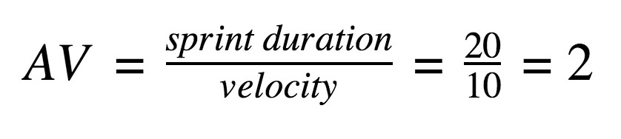

**Burndown Chart:**

A burn down chart is a graphical representation of work left to do versus time. It is often used in agile [software development](https://www.visual-paradigm.com/scrum/what-is-agile-software-development/) methodologies such as [Scrum.](https://www.visual-paradigm.com/scrum/scrum-in-3-minutes/) However, burn down charts can be applied to any project containing measurable progress over time.

